**SPRINT 1 DELIVERABLES**

1. **We analyzed the given**[**data**](https://github.com/IBM-EPBL/IBM-Project-14297-1659548839/blob/main/final%20deliverables/data/dataset_website.csv)**and**[**experimented**](https://github.com/IBM-EPBL/IBM-Project-14297-1659548839/blob/main/project%20development/sprint%201/Preprocessing%26ModelBuilding.ipynb)**with various classification models like Decision Tree, Random Forest, XGBoost and Support Vector Machines. We ranked the performances of all these models. We found that XGBoost classifier worked well with our data.**

**[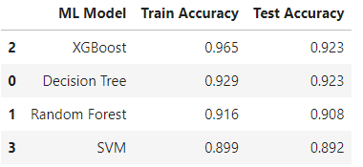](https://user-images.githubusercontent.com/64459672/199572696-3e71faea-1d90-4561-9e1b-c2149632fb5c.png)**

1. **We designed our**[**home page**](https://github.com/IBM-EPBL/IBM-Project-14297-1659548839/blob/main/project%20development/sprint%201/index.html)**with a form field to get URL input from the user to check its genuineness. The home page also has other components expounding the serives we offer and the team.**

**[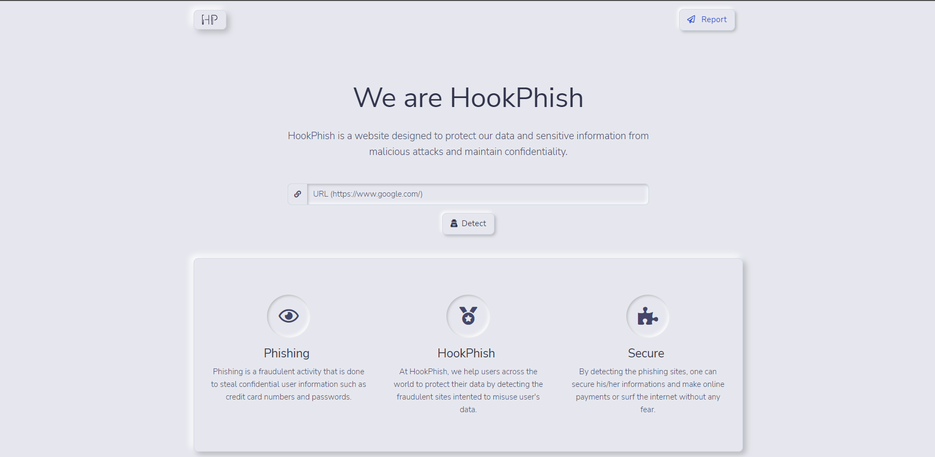](https://user-images.githubusercontent.com/64459672/199573563-36d04091-d771-4a06-8809-288b432164c6.png) [](https://user-images.githubusercontent.com/64459672/199573555-2b323eee-2969-4480-91ce-23db4d0d523c.png)**